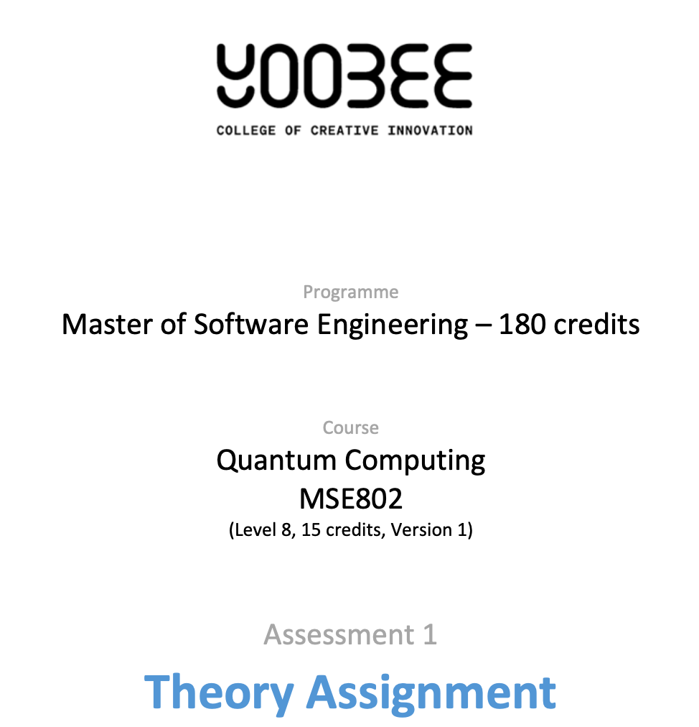
Task 3: Quantum Tic-Tac-Toe
Code Analysis
MSE802 Quantum Computing | Assessment 2
Student: Wijemuni Rukshan Madushanka De Silva
Student ID: 270802602
Tutor/Lecturer: Arun Kumar
Institution: Yoobee College
Submission Date: 06/04/2026

Abstract

This document presents an analysis of a quantum Tic-Tac-Toe implementation designed to demonstrate the principles of quantum computing through interactive gameplay. The game uses a 9-qubit quantum circuit, one qubit per board cell, where player moves correspond to quantum gate operations including Pauli-X, RY rotations, and SWAP gates. The code was completed by implementing the missing make_move() and countWinners() functions and adapted from Google Collab to run locally using Qiskit and ipywidgets. The document provides a function-by-function explanation of the code, an analysis of the quantum gates employed, gameplay dynamics, winning strategies for both players, and a theoretical discussion of how quantum superposition and measurement collapse govern the game outcome.
Table of Contents
1. Overview of the Game 4
2. How the Quantum Circuit is Generated 4
3. Quantum Gates Used 5
3.1 Not — Pauli-X Gate 5
3.2 O Move — RY(−π/4) Rotation 5
3.3 X Move — RY(+π/4) Rotation 5
3.4 SWAP Gate 6
4. Completing the countWinners() Function 6
5. Gameplay Analysis 7
6. Winning Strategies 8
Player X — Diagonal Control Strategy 8
Player O — Anti-Diagonal Blocking Strategy 8
7. Adapting from Google Collab to VS Code 8
8. Quantum Behavior and Theoretical Insight 9
9. Limitations of the Model 9
10. Real-World Applications 9
11. Conclusion 10
References 10

1. Overview of the Game
Quantum Tic-Tac-Toe is a quantum variant of the classic game where each cell on the 3×3 board is represented by a qubit instead of a fixed X or O marker (Nielsen & Chuang, 2010). The game was originally proposed by Goff (2006) as a teaching tool to demonstrate quantum superposition in an intuitive and engaging way (Goff, 2006).
In the classical version, each cell is definitively owned by one player from the moment it is marked. In the quantum version, each cell exists in superposition; it has some probability of belonging to X and some of belonging to O until the board is measured (Nielsen & Chuang, 2010, p. 2). At that point, the quantum state collapses, and each cell becomes definitively owned by one player.
The board is represented by a 9-qubit quantum circuit (one qubit per cell) and 9 classical bits that store the measurement results (Qiskit Contributors, 2024).

2. How the Quantum Circuit is Generated
The circuit is built progressively as players make moves rather than being predefined. The game starts by initializing all 9 qubits in superposition using Hadamard gates (Nielsen & Chuang, 2010, p. 18):
for idx in range(9):
self.qc.reset(idx)
self.qc.h(idx) # superposition
Each player’s move appends one or more gates to the circuit. Because no measurement happens until the end of the round, all the moves accumulate on the same circuit.
When the Measure button is clicked, a barrier is added, each qubit is measured into its corresponding classical bit, and the AerSimulator runs the circuit for a single shot one definitive outcome per cell (Qiskit Contributors, 2024).
From a circuit perspective, each move modifies the quantum state vector of the system by applying unitary transformations. The Hadamard gates initialize each qubit into an equal superposition, while subsequent rotations and gate operations alter the probability amplitudes associated with each basis state. As these transformations accumulate, the circuit encodes a complex probability distribution that determines the final measurement outcome.
This single-shot measurement is what makes the game quantum the outcome is probabilistic and weighted by all the gates applied during the round, but once measured, it is irreversible (Nielsen & Chuang, 2010, p. 84).
This demonstrates how quantum circuits can be dynamically constructed rather than statically defined.

3. Quantum Gates Used
There are four move types available during gameplay, each mapping directly to a quantum gate operation on the circuit (Nielsen & Chuang, 2010, p. 18).

3.1 Not — Pauli-X Gate
Applies a Pauli-X gate to the selected qubit (Nielsen & Chuang, 2010, p. 17). The X gate flips the qubit — if it was biased toward |0⟩, it becomes biased toward |1⟩ and vice versa. In game terms, it transfers a cell from one player’s influence to the other.
self.qc.x(int(cell)) # Qiskit Pauli-X gate (Qiskit Contributors, 2024)

3.2 O Move — RY(−π/4) Rotation
Applies an RY(−π/4) gate, rotating the qubit’s state vector on the Bloch sphere toward the |0⟩ pole (Nielsen & Chuang, 2010, p. 15). In this implementation |0⟩ maps to X after measurement, so applying O increases the probability that the selected cell goes to X. Multiple O moves on the same cell push it closer to a guaranteed X outcome.
self.qc.ry(-np.pi / 4, int(cell)) # RY rotation (Qiskit Contributors, 2024)

3.3 X Move — RY(+π/4) Rotation
Applies an RY(+π/4) gate, rotating the qubit toward the |1⟩ pole (Nielsen & Chuang, 2010, p. 15). Since |1⟩ maps to O after measurement, this increases the probability of an O outcome on the selected cell.
self.qc.ry(np.pi / 4, int(cell))

3.4 SWAP Gate
Applies a SWAP gate between two selected qubits, exchanging their entire quantum states (Nielsen & Chuang, 2010, p. 23). All accumulated rotations and phase information are transferred. This is a strong strategic move a player can build up a favorable qubit state in one cell and then swap it into a more tactically important position before measurement.
self.qc.swap(int(self.target), int(cell)) # (Qiskit Contributors, 2024)
These gate operations can be interpreted as unitary transformations acting on the qubit state vector. Each operation preserves the total probability while redistributing amplitude between the basis states |0⟩ and |1⟩, which directly influences the likelihood of each measurement outcome.

4. Completing the countWinners() Function
The original code had an empty tuple for the win conditions, so the function always returned 0. I completed it by adding all 8 winning lines for a 3×3 board, three rows, three columns, and two diagonals (Goff, 2006):
winners = (
(0, 1, 2), # top row
(3, 4, 5), # middle row
(6, 7, 8), # bottom row
(0, 3, 6), # left column
(1, 4, 7), # middle column
(2, 5, 8), # right column
(0, 4, 8), # diagonal ↗
(2, 4, 6), # diagonal ↖
)
After measurement, each cell is definitely X or O. The function checks each triple and counts how many complete winning lines belong to the given player. Unlike classical tic-tac-toe, both players can simultaneously complete winning lines in the same round because all 9 qubits collapse at once (Goff, 2006; Nielsen & Chuang, 2010, p. 84).

5. Gameplay Analysis
Playing the game a number of times revealed several interesting behaviours that differ from the classical version:
- Outcomes that are inherently probabilistic due to quantum superposition and measurement collapse. Even with identical move sequences, the final board state varies between rounds. The AerSimulator runs with shots=1, so each measurement collapses the quantum state to a single outcome sampled from the probability distribution built up by the moves (Qiskit Contributors, 2024; Nielsen & Chuang, 2010, p. 84).
- Cumulative rotations. Applying X to the same cell multiple times keeps rotating the qubit further toward |1⟩ (Nielsen & Chuang, 2010, p. 15). Applying both X and O to the same cell partially cancels the effect, leaving the cell closer to 50/50.
- SWAP as a strategic tool. The SWAP gate transfers the full quantum state of one qubit to another (Nielsen & Chuang, 2010, p. 23). A player can accumulate a strong bias in one cell and then swap it to a more important position before measuring.
- Multiple simultaneous winners. Because all 9 qubits collapse at once, it is entirely possible for both players to complete winning lines in the same round (Goff, 2006). The scoreboard counts all wins for each player independently.
- Entanglement-like correlations. Although explicit entangling gates are limited, the cumulative effect of operations across qubits creates interdependent outcomes. The final measurement reflects a global state rather than independent classical decisions, meaning the board outcome is influenced by the entire circuit rather than individual moves.
These behaviours indicate that the system is not evolving as independent classical variables, but as a combined quantum state where the final outcome depends on the cumulative transformation of the entire system.

6. Winning Strategies

Player X — Diagonal Control Strategy
Player X applies RY(π/4) gates to cells 0, 4, and 8 on the main diagonal. Each RY(π/4) rotation increases the probability amplitude of measuring |1⟩ on that qubit to approximately 0.854, compared to 0.5 for a qubit in superposition.
By applying the gate twice to a cell, the probability of measuring |1⟩ rises further toward 1.0. This strategy maximizes the likelihood that all three diagonal cells collapse to |1⟩ upon measurement, satisfying the win condition (0, 4, 8). The diagonal is targeted because it is the most direct win condition, requiring only three non-overlapping cells.

Player O — Anti-Diagonal Blocking Strategy
Player O applies RY(-π/4) gates to cells 2, 4, and 6 on the anti-diagonal. The negative rotation reduces the probability amplitude of measuring |1⟩, effectively competing with Player X for control of the center cell (qubit 4). Since both players apply gates to qubit 4, the final state of that qubit depends on the cumulative rotation applied. If Player X applies RY(π/4) twice and Player O applies RY(-π/4) once, the net rotation is RY(π/4), still favoring |1⟩. Player O’s strategy is most effective when it applies more gates to shared qubits to shift the probability distribution away from Player X’s winning configuration.

7. Adapting from Google Collab to VS Code
The original notebook imported google.colab.widgets.Grid for the interactive board layout. This API is Collab-specific and not available in standard Jupyter environments. For this submission, the display was rewritten using ipywidgets.HBox and VBox, which produce the same 3×3 grid layout and are fully supported in VS Code’s Jupyter extension (ipywidgets developers, 2024).
The interactive logic (button callbacks, clear_output, handle_game) remains unchanged; only the layout rendering was adapted.

8. Quantum Behavior and Theoretical Insight
The behavior observed in the game is a direct result of quantum superposition and measurement collapse. Each qubit exists in a linear combination of |0⟩ and |1⟩ states, and the applied quantum gates modify the probability amplitudes associated with these states. Unlike classical systems, where outcomes are deterministic, the quantum system evolves probabilistically until measurement occurs.
The final board configuration is determined only at the point of measurement, where all qubits collapse simultaneously into classical states. This explains why identical sequences of moves can produce different outcomes across multiple runs. The probabilistic nature of quantum mechanics is therefore directly reflected in the gameplay experience.

9. Limitations of the Model
While the implementation effectively demonstrates quantum principles, it relies on a simulator rather than real quantum hardware. As a result, it does not capture real-world issues such as noise, decoherence, and gate errors. Additionally, the use of a single-shot measurement simplifies the probabilistic nature of the system. Running multiple shots would provide a more accurate distribution of possible outcomes rather than a single sampled result.

10. Real-World Applications
The concepts demonstrated in this game are relevant to real-world quantum computing applications such as quantum optimization, quantum simulation, and quantum machine learning. These systems also rely on manipulating quantum states through sequences of operations before performing measurements. The game provides an intuitive way to understand how quantum circuits evolve and how probabilistic outcomes emerge from quantum processes.

11. Conclusion
This implementation successfully demonstrates how quantum computing principles can be applied in an interactive context. By mapping board cells to qubits and player moves to quantum gate operations, the game illustrates core concepts such as superposition, measurement collapse, and probabilistic outcomes in an intuitive way. The completed make_move() function correctly applies the appropriate gate for each player action, while countWinners() evaluates all eight win conditions after measurement collapses the quantum state.
Unlike classical Tic-Tac-Toe, the outcome of this game is inherently probabilistic due to quantum superposition and measurement collapse — identical move sequences can produce different board results across multiple runs. This highlights a fundamental property of quantum systems: the final state is not determined until measurement occurs. The implementation serves as an effective educational tool for understanding how quantum circuits evolve through user interaction, and how real-world quantum concepts such as unitary transformations and probability amplitude manipulation translate into practical applications.

References
Goff, A. (2006). Quantum tic-tac-toe: A teaching metaphor for superposition in quantum mechanics. American Journal of Physics, 74(11), 962–973.
ipywidgets developers. (2024). ipywidgets documentation. https://ipywidgets.readthedocs.io
Nielsen, M. A., & Chuang, I. L. (2010). Quantum Computation and Quantum Information. Cambridge University Press.
Qiskit Contributors. (2024). Qiskit documentation. IBM Quantum. https://docs.quantum.ibm.com

